Overview - Optimizing Neural Networks

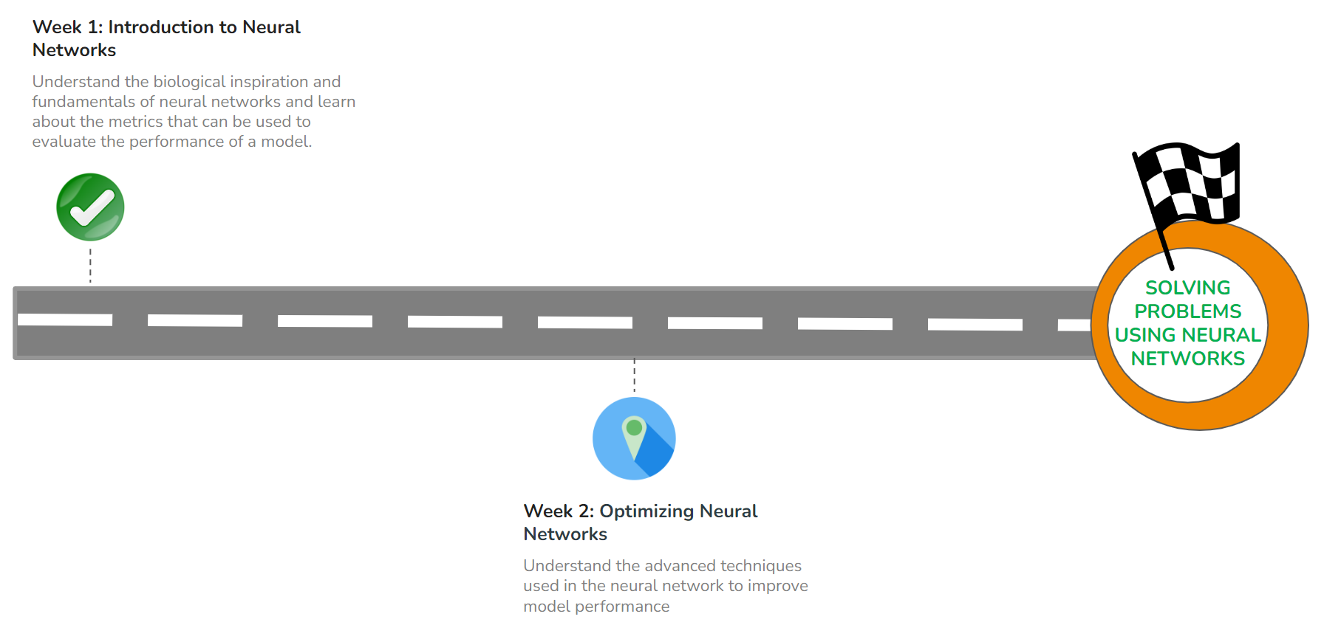

#### **QUICK RECAP**

In the previous week, we learned about the basic concepts of Neural Networks. Let us quickly recap what we have covered so far.

* Deep Learning and History
* Multi-Layer Perceptron
* Types of Activation Function
* Types of Loss Loss functions
* Training Neural Networks

#### **COURSE OVERVIEW**

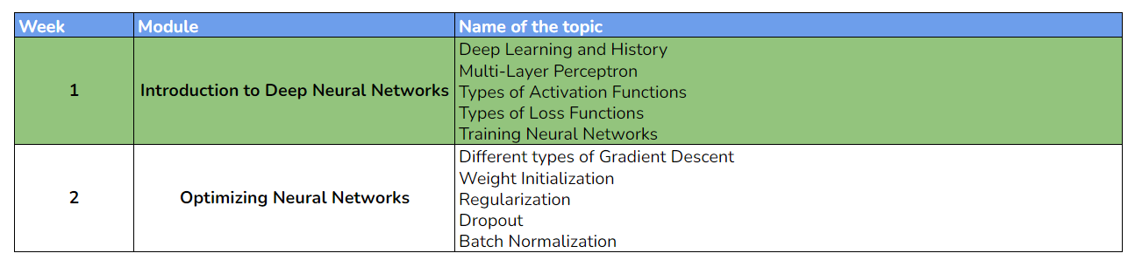

#### **WEEK 2 OVERVIEW**

This week, we will be learning about the building blocks of a neural network model and a few advanced techniques to improve the model. The following topics will be covered in this module:

* Different types of Gradient Descent
* Weight Initialization
* Regularization
* Dropout
* Batch Normalization

#### **LEARNING INSTRUMENTS**

| **Week** | **Module** | **No. of videos** | **Total duration** | **No. of Test Your Understanding Quizzes** | **No. of Weekly Graded Quizzes** |
| --- | --- | --- | --- | --- | --- |
| **2** | **Optimizing Neural Networks** | 12 | ~2.5 hours | 12 | 1 |

#### **Note: It is recommended to spend at least 1 hour/day along with practicing datasets and quizzes.**

**Power Ahead!**